Geometry Shader - Explanation

To generate a star from within the geometry shader I first pass down a single point using a single vertex and point list topology through the pipeline. The vertex shader performs no transforming. The geometry then takes the point as a mid-point of the star. From this point I generate 10 new points that sit along the inner and outer rings of the star.

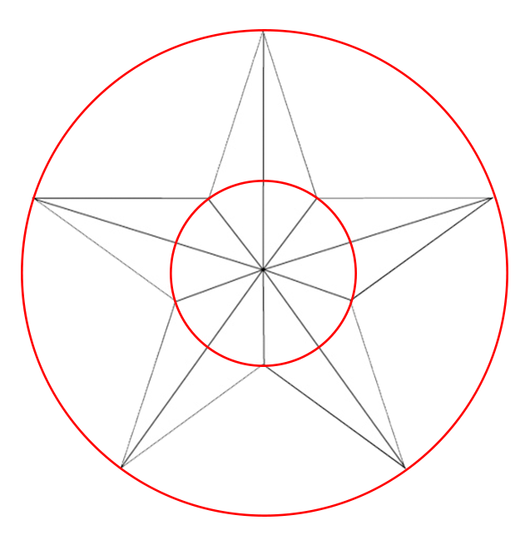

From this I generate a triangle list of ten triangles to form the star. Two triangles per point of the 5 point star. The first triangle defined from an outer point to the centre to the inner point. The second triangle defined from an outer point to an inner point to the centre point.

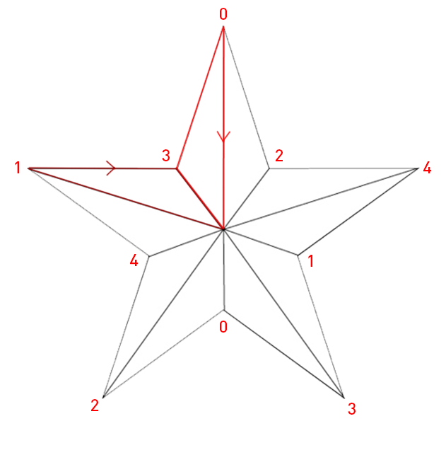

The geometry shader also transforms each vertex of the star by the world view projection matrix to get the matrices into screen space.